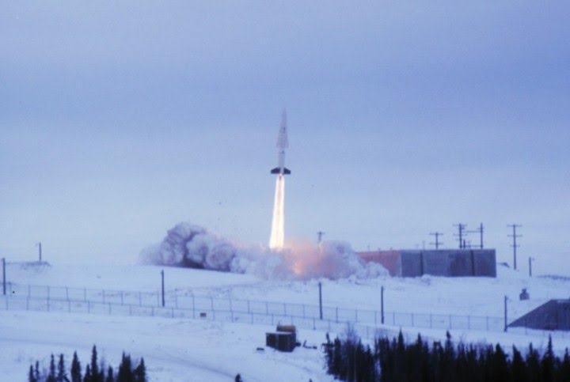

ALASKA’S COLD WAR NUCLEAR SHIELD

Bob Raichle

© 2012
ALASKA’S COLD WAR NUCLEAR SHIELD
Author: Bob Raichle
For more than twenty years, the state of Alaska was the first stop for Soviet bombers on the way to the lower 48. Flying over Alaska was the shortest distance between Soviet bomber bases in Russia and strategic targets in the lower 48. The United States recognized this threat and initiated many programs to give early warning of a Soviet bomber attack and to defend against this attack. A prime example is the DEW (Distant Early Warning) line of long range radars which gave the United States early warning of an impending bomber attack. Another program is the NIKE HERCULES air defense system, a system which provided a nuclear shield for strategic Alaskan military bases from 1959 to 1979.
After the Second World War, the United States recognized that the tension and competition between the west and the Soviet Union increased to a point that intercontinental nuclear war, characterized by large numbers of nuclear bombs being delivered by fleets of Soviet bombers and later intercontinental ballistic missiles, was a very real threat. This led the United States to develop an advanced air defense capability designed to intercept and neutralize a Soviet bomber attack. The NIKE series of air defense missiles replaced the aging anti-aircraft batteries which were leftovers from World War II. The first iteration was the NIKE AJAX, a two stage missile with a conventional high explosive warhead and limited range. NIKE AJAX sites were built around strategic targets in the lower 48 states, located mainly around major cities and military bases. No NIKE AJAX sites were built in Alaska.
Recognizing that the NIKE AJAX missile system was woefully inadequate to stop massive waves of Soviet bombers loaded with nuclear weapons targeted to destroy United States cities, the NIKE HERCULES missile system was developed. The NIKE HERCULES system had missiles with longer ranges and which could achieve higher altitudes, which were important to bring down the Soviet bomber threat. More importantly, the NIKE HERCULES missiles employed nuclear warheads. This very important capability allowed nuclear explosions to bring down Soviet bombers flying in high altitude formations. The nuclear blast and resulting radiation would result in “weapons kill” by either knocking the Soviet bombers out of the sky or rendering the Soviet nuclear weapons inoperable. In either case, mission accomplished. NIKE HERCULES had done its job. To this day, the NIKE HERCULES missile system was the most capable and effective area air defense missile system ever fully deployed on U. S. soil. Attempts to develop more effective systems were later scrapped due to the advent of ICBM’s and the Anti-Ballistic Missile Treaty, agreed to in the early 1970’s.

THE NIKE HERCULES SYSTEM
The NIKE HERCULES system is a fixed location ground based air defense system that employs guided missiles to seek and destroy planes. The systems were organized into area defenses employing firing sites, called batteries. Each battery employed a series of acquisition and tracking radars which identified and tracked incoming airborne targets. Each firing battery had a secured area which contained the radar equipment and controlled the entire operation of the battery, including the firing of the missiles with nuclear warheads. This control area (known as the Integrated Fire Control area, or IFC) provided overall command and control of the battery’s firing mission and had line of sight to a second secured area, the launching area, where the missiles were stored and launched. NIKE HERCULES batteries were easily identified by the large “golf ball” radar domes which protected the radars from the elements and allowed the radars to perform their long range acquisition and tracking functions during periods of bad weather and high winds.
Each firing battery was an independent site, with power generators, troop housing and administrative area, and the ability to perform its mission with little outside help. Each firing battery had 100 enlisted and officer personnel and was supported by on-site civilian personnel. Maintenance and technical support functions were provided by an off-site military direct support ordnance company which maintained the radars, computer, and warheads. Each firing battery was a highly secured site, with double fencing, razor wire and roving security patrols comprised of military police personnel and large sentry dogs. Since nuclear weapons were being secured, the roving guards were armed and were authorized to use deadly force against intruders if necessary.
The technical specifications of the NIKE HERCULES system were impressive, even by 21st century standards. The acquisition radars could see more than 100 miles out, and the missiles had an altitude capability in excess of 150,000 feet, a range more than 88 miles, and could reach speeds in excess of 3,000 miles per hour (Mach 3.5). Each site could engage a target and launch a missile every 2 minutes and would direct the missile to a specific burst point, above and in the front of the oncoming Soviet bombers. The nuclear warheads came in several sizes, the largest of which had a yield of 40 kilotons (roughly 3 times the yield of the Hiroshima bomb).
Given the longer range and nuclear capability of the NIKE HERCULES missile system, the NIKE AJAX systems were phased out or converted to NIKE HERCULES installations. More than 145 NIKE HERCULES sites were deployed in the United States in the late 1950’s and early 1960’s with the majority of the sites converted from existing NIKE AJAX sites. Major target areas, such as New York, Washington, D. C., Los Angeles and San Francisco were surrounded by multiple integrated firing batteries, in some cases more than 12 firing batteries. Other defense areas were located around major military bases (Strategic Air Command bases which were the home to the United States bomber fleet, for example) and around other strategic locations (nuclear weapons production facilities and major military headquarters). Each area “defense” was controlled by an Army air defense command post, known as AADCAP’s. The AADCAP provided command and control of the firing batteries and directed the air defense battle, integrating the activities of the firing batteries, Air Force fighter interceptors, and other air defense resources.
NIKE HERCULES IN ALASKA
Alaska’s nuclear air defense shield was put into place in the late 1950’s with the building of eight nuclear capable NIKE HERCULES air defense missile sites (firing batteries), five sites in the “Fairbanks defense” area, which consisted of Fort Wainwright and Eielson Air Force Base, and three sites (including one with a double launching area) in the “Anchorage defense” area, which consisted of Fort Richardson and Elmendorf Air Force Base. With each Alaskan firing battery armed with 14 NIKE HERCULES missiles carrying a nuclear warhead with a yield ranging from 20 kilotons to 40 kilotons, the total nuclear yield of the Alaska air defense missile sites was more than 5 meta-tons of nuclear destruction. The missile sites were organized under two battalions and were part of the 87th Artillery Group headquartered at Fort Richardson and under the command of the United States Army Alaska.

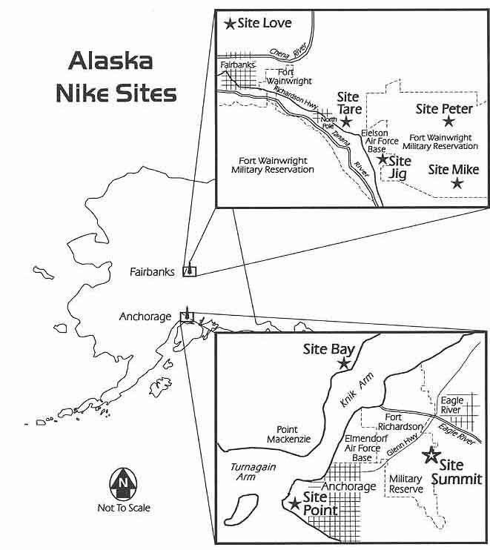

THE ANCHORAGE DEFENSE
Served by the 4th Missile Battalion, 43rd Artillery, the Anchorage defense’s prime mission was to protect Fort Richardson and Elmendorf Air Force Base, which was home to the air defense command and control facilities and aircraft on Elmendorf and the troop concentrations on Fort Richardson. Elmendorf AFB also housed Air Force fighter interceptors which would fly out to meet and destroy the invading Soviet bombers in advance of the use of NIKE HERCULES missiles. However, the interceptors were armed with air to air missiles which carried small nuclear warheads with yields less than the yields of the NIKE HERCULES warheads and which would do only initial damage to the large numbers of Soviet bombers which would come. The NIKE HERCULES missile sites had larger nuclear warheads which would do the bulk of the damage to the bomber fleet. The Anchorage defense consisted of three firing batteries plus a headquarters battery for administrative control. The Anchorage batteries were initially supported by the 194th Ordinance Detachment and later by the 524th Ordnance Company, both of which provided direct maintenance support and technical support of the sites and the nuclear weapons.
The firing batteries were under the tactical control of the Army Air Defense Command Post (AADCAP) which was initially located at the NORAD control center at Fire Island and later moved to A Battery at Site Point, located near the Anchorage airport. Unlike the NIKE HERCULES batteries which were controlled by NORAD commanders in the lower 48, the Alaskan batteries were under the command and control of the Alaskan NORAD Region Command Center and the Commander, Alaskan Command, who would authorize the use of nuclear weapons should a Soviet attack occur. The firing batteries were Site Point (A Battery, the dual launching site which was located near the Anchorage airport); Site Summit (B Battery, located in the Chugach Mountains 4,000 feet above Anchorage), and Site Bay (C Battery, which was located in the Knik Arm of the Cook Bay inlet at Goose Bay across from Fort Richardson).
The Alaskan NIKE HERCULES sites were unique from similar sites in the lower 48 due to the extreme weather and terrain conditions found in Alaska. For example, instead of the underground missile storage magazines used in the lower 48, the Alaskan missiles were stored above ground in reinforced concrete bunkers. The tracking radars were positioned on top of radar towers and were enclosed in steel “clamshells” which could be closed to maintain the radars during inclement weather. Construction of the Alaskan sites required careful planning and design to allow for the unique weather and terrain. The three Anchorage sites were built by Patti McDonald Co. and M-B Contracting Co. in the late 1950’s for less than $10 million. Site Summit, located more than 4,000 feet above Anchorage, was especially difficult to build. The IFC (battery control) area was placed on top of an area in which 60 vertical feet had to be blasted off of the mountaintop and more than 25,000 cubic yards of rock removed to make an area for the site. Concrete for the battery control buildings, which were anchored to the ground with steel rods anchored in concrete pads due to the high wind conditions, and the missile magazine bunkers, had to be poured In weather conditions conducive to pouring concrete, conditions which were hard to achieve due to constant extreme weather. These unique conditions added significantly to the costs to build Site Summit.
During the period of time that the Anchorage NIKE HERCULES sites provided air defense for the Fort Richardson/Elmendorf AFB/Anchorage complex, the Cuban missile crisis dominated the news. In October, 1962, it was clear that tensions between the Soviet Union and the United States were reaching the boiling point. Although Cuba was thousands of miles away, in response to the higher defense condition (DEFCON) at this time, the Alaskan NIKE sites were locked and loaded with missiles on launchers and sites on a “five minute” status, i.e. ready to fire in 5 minutes. The troops were at this status for more than 30 days, as President Kennedy dealt with the crisis. Also of note during the 20 year period NIKE HERCULES protected Alaska was the Good Friday earthquake experienced in March of 1964. Although damage to the battery’s buildings was minor, several missiles stored in the magazines were knocked off their launchers and, upon inspection, were determined to be in dangerous condition. However, although the nuclear warheads were not armed, the warheads were part of the missile tangle in the magazines which had to be rendered safe, then sorted out, inspected, and secured.
It did not take long to see the overall impact of the NIKE HERCULES sites on the Anchorage community. Millions of dollars were pumped into the local economy as a result of the sites. Long time Anchorage residents would remember the large Christmas star which was placed below the launch area of Site Summit. And early in Site Summit’s history, the Alaskan NIKE HERCULES missile sites conducted annual service practice at Site Summit. This practice was used to evaluate the training and readiness of the missile crews and involved a live firing of a NIKE HERCULES missile from Site Summit. As the Anchorage area grew, the annual firings were moved to Site Peter in the Fairbanks defense, which was located east of Eielson Air Force base and which provided a large uninhabited firing range at the US Army Alaska Yukon Missile Range east of Fairbanks.
The Anchorage sites were deactivated and closed in 1979, with the missiles, warheads, and equipment transferred to the lower 48. Several buildings at Site Point were converted to a ski chalet facility. Site Bay was used for prisoner housing and later demolished. Site Summit was the last site deactivated and closed in July of 1979. The remnants of Site Summit exist today and restoration of the site began in 2010. The site is being preserved as a National Historic Site and once restored plans include guided tours and interpretive displays.

THE FAIRBANKS DEFENSE
Served by the 2nd Missile Battalion, 562nd Artillery, the mission of the Fairbanks defense was to provide for the air defense of the Fort Wainwright/Eielson Air Force base/Fairbanks military complex. Like the Anchorage area, the Fairbanks defense provided the protective nuclear umbrella for the Air Force’s KC-135 tanker fleet at Eielson AFB which would refuel the United States bombers from the lower 48 on the way to targets in Russia. Eielson also was home to fighter interceptors (F102’s, F-4 Phantoms, and later F106’s) which would fly out to engage intruding Soviet air force bombers and escort aircraft. Other military assets in the Fairbanks area were Fort Wainwright and Ladd Air Force base, which was turned over to the Army in 1961. Ironically, Ladd Field was the “transfer” location for United States aircraft being shuttled to Russia during World War II. Finally, there was the super-secret and not talked about Air Force unit which flew the U-2 spy plane to gather intelligence data over the Soviet Union. The U-2 was frequently observed taking off and landing on daily spy missions at Eielson AFB. The NIKE HERCULES sites were not officially advised about the U-2 flight schedule, but sites in the Fairbanks defense, especially SITE LOVE, observed the U-2’s flight activity frequently.
As the planning for the Fairbanks defense evolved in the mid 1950’s, eight NIKE HERCULES sites were initially planned. When Ladd AFB was turned over to the Army and renamed Fort Wainwright, the four sites planned to defend Ladd AFB were eliminated. However, the Army decided to build one site, SITE LOVE, to protect the western flank of the Fairbanks area and to integrate the firepower of the four NIKE HERCULES sites surrounding Eielson AFB. SITE LOVE was the northernmost NIKE HERCULES missile site in the United States and was the first NIKE HERCULES missile site the Soviet bombers would face on their way to the lower 48.
The Fairbanks NIKE HERCULES sites were built in the late 1950’s by Peter Kiewit Son Co. for a contract cost of almost $13 million. The construction of Site Love was accomplished by B-E-C-K Constructors at a cost of $3 million. As with the Anchorage sites, weather and terrain played a factor in timely completion of the sites. However, the four Fairbanks sites around Eielson Air Force base were finished and on line in mid-1959. SITE LOVE was finished and put on line in late 1960.
The Fairbanks defense consisted of the five firing batteries, plus a headquarters (administrative) battery. Technical and maintenance support for battery equipment and warheads was provided by the 166th Ordnance Company. Operational command and control for the Fairbanks defense and firing batteries was conducted by the NORAD control center at Murphy Dome, an Air Force radar center located northwest of Fairbanks and near SITE LOVE. Access to the sites was strictly limited to military personnel with security clearances, but civilians could easily drive to the sites on public access roads and view both the IFC (control) areas and, if they were lucky, see the missiles on the launchers outside the missile magazines in the launcher area during military exercises and frequent maintenance activities. Ironically, the batteries received classified messages telling them to put the missiles away when Soviet satellites were overflying the sites, but one could drive up to the launching area and take pictures of the missiles from outside the double fences protecting the missiles. It is unknown whether or not Soviet spies took this opportunity to study the capabilities of the sites from this vantage point.
The five Fairbanks batteries were on duty from 1959 to 1971, at which time reductions in the military budgets due to the Vietnam War led to the deactivation and closing of the Fairbanks batteries in 1970-1971. The batteries were deactivated and equipment and missiles, plus warheads, were dismantled and shipped back to equipment and warhead storage areas. Control buildings at the batteries were destroyed and bulldozed in open pits which were then covered with dirt. Some control buildings, as well as some concrete magazines, were spared and today serve as storage facilities for local companies and civic entities. Spanning several decades of utilizing anti-aircraft guns and later NIKE HERCULES missiles, the era of air defense was over for the Fairbanks defense. Except for limited fighter-interceptor resources placed at Eielson AFB, for the first time since World War II, Fairbanks had no air defense.

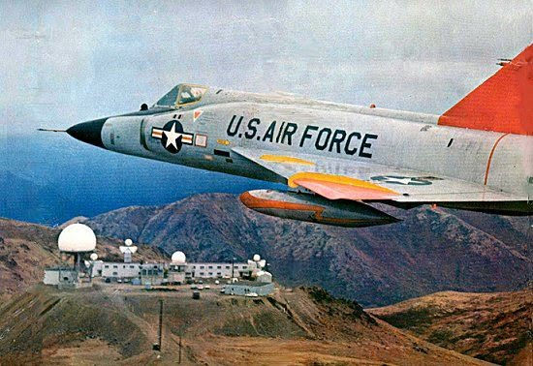

ALASKAN NIKE HERCULES TACTICAL OPERATIONS
Cold War debriefings of Soviet pilots reveal that they were well aware of the NIKE HERCULES batteries defending Alaska and the lower 48 targets, but flying around the Alaskan defenses would consume unacceptable amounts of fuel. Consequently, in order to clear a path of attack to the lower 48, each Alaskan NIKE HERCULES battery was targeted with more than 250 kilotons of nuclear devastation. As indicated earlier, the batteries were easily identified by their “golf ball” silhouette and their locations, originally secret, were well known and Soviet satellites overflying the batteries could easily target the batteries.
The air defense threat posed by the Alaskan NIKE HERCULES batteries was well known and elimination of the Alaskan NIKE HERCULES sites was a major element of the Soviet battle plan. The Soviets were so concerned about the NIKE HERCULES defensive capabilities that they recruited a high ranking US Army officer who had been involved in the development of the missile system and who could provide classified details about the system’s capabilities and deployment. Classified system documents, including radar schematics and plans, were discovered in the military sections of Russian libraries after the Cold War was over.
The Alaskan NIKE HERCULES batteries could also execute a surface-to-surface firing mission, meaning that the batteries could deliver a 40 kiloton nuclear warhead to a target up to 100 miles away from the battery. This capability was added to the Alaskan batteries in the event of a Soviet ground invasion of Alaska. This may seem farfetched, but the Soviet plan to dominate the world included invasion and occupation of neighboring countries. The surface-to-surface mission was added for the NIKE HERCULES batteries (the surface-to-surface capability was critical to the battery’s mission, and was part of the evaluation of each battery utilizing live missile firings every year). NIKE HERCULES missiles in the surface-to-surface role were the most accurate artillery weapon in the Army’s arsenal at that time.
The mission of shooting down large formations of incoming bombers armed with nuclear weapons with fixed missile sites also armed with nuclear weapons required close coordination of all military assets and strict operating guidelines and rules of engagement. All combat operations were coordinated and centrally controlled by the AADCAP’s at the NORAD Control Center in each defense area. If the AADCAP was put out of action by invading bombers, the NIKE HERCULES could operate autonomously using electronic methods to identify friend versus foe aircraft and pre-designated safe flying corridors for friendly aircraft. The NORAD control center would manage the air battle integrating the fighter interceptor resources and NIKE HERCULES batteries with the long range radar data from the DEW line and other remote early warning acquisition radars. The NORAD Control Centers were Air Force installations whose role was to manage the air space for their area of responsibility and to manage the air battle when the Soviet bombers came. In this role, these centers controlled all airspace activities and directed fighter-interceptors and later NIKE HERCULES missiles to their targets. This was especially important as the Soviets constantly probed the air defenses of Alaska by flying aircraft up to the western coast of Alaska, and then fly zigzag patterns up and down the coast to see how the United States forces would respond. Frequently, the Soviets would send aircraft directly at the coast of Alaska and turn around when they were detected and fighter interceptor aircraft were scrambled to head off the possible threat. The NIKE HERCULES batteries were also called up to a higher readiness status until the threat was over. Sometimes these games lasted all night, but eventually the Soviets would return to base. As the United States fighter interceptors returned to base, they were tracked by the NIKE HERCULES batteries all the way back to their home base. The returning fighter jets were always low on fuel and the NIKE HERCULES battery radars could pinpoint their position if they went down.
Command and control of the nuclear warheads at the NIKE HERCULES batteries was very tight. No one was authorized to be in the launcher area without a companion (the two man rule). Any type of flame producing materials (matches, lighters) was forbidden and the physical security of the missiles with their nuclear warheads was insured by roving military police patrols with large sentry dogs and loaded weapons. The use of deadly force was authorized to secure the NIKE HERCULES missiles and warheads. Frequent security inspections were conducted which included attempts to breach the security of the launcher areas in the middle of the cold Alaskan night.
In the event of an actual incursion by Soviet bombers, a strict line of control authorizing the release of nuclear weapons was in place. Upon release authorization from the President of the United States, the release order would travel down the chain of command with frequent TOP SECRET coded authentications of the release order. At the battery level, the release order would be confirmed by two individuals (a commissioned officer on one team and a warrant officer or senior non-commissioned officer on another team) who would open a safe with two combinations, each individual knowing only one combination (two man control again). At the battery level, the nuclear release authorization would be confirmed using TOP SECRET authorization codes and the final preparations to fire the missiles with the nuclear warheads were completed. These security measures, along with other methods of securing access to the batteries radars and missiles, ensured that each firing battery was totally secure and ready to perform its mission when called upon.
Given the high level of technology and maintenance requirements at each firing battery, especially critical in the extreme weather conditions experienced at the Alaskan sites, the readiness condition of the batteries were rotated on a weekly basis, with one battery designated the “HOT” battery (ready to fire in 15 minutes) and the other batteries in the defense at lower status yet ready to respond quickly to a call up in readiness. “HOT” batteries were locked and loaded and ready to go, with equipment checks conducted hourly and tracking of live targets (usually commercial airliners) done regularly. The troops at the “HOT” battery lived and slept at their stations and were ready to go at moment’s notice. If the “HOT” battery experienced equipment problems rendering the battery unable to fire, the next battery in line (and at the lower status) would be called up to “HOT” status.
As the 1960’s unfolded, the NIKE HERCULES system equipment was being constantly improved to increase their effectiveness. Significant enhancements were made to the electronic countermeasures (ECM) capabilities of the NIKE HERCULES radars to counter advancements in the Soviet’s capability to jam these radars and render them less capable or even totally ineffective. Equipment was developed which would hook up to the battery’s electronic systems, giving the capability of simulating target acquisition, tracking and firing exercises and training electronically without the need for a live target. A major improvement was made in the mid-1960’s to the acquisition and tracking radars and related systems which gave the Alaskan NIKE HERCULES batteries the capability to acquire, track and shoot down an incoming ICBM. This new defensive capability, which was the precursor to today’s ballistic missile defense, was implemented at limited NIKE HERCULES locations. The Alaskan NIKE HERCULES batteries were selected to have this improvement due to their location and importance to the air defense integrity of the United States. It is interesting to note that these improvements to the NIKE HERCULES radar systems were developed at the famous “non-existent” research and development site known as Area 51 in Nevada.
The rules of engagement for the NIKE HERCULES batteries were very specific and gave the individual battery control officers little room for variance. All actions were scripted with every team member having specific responsibilities. The chain of command rules authorizing firing a missile were very clear, and extensive safety rules were in place to prevent the unauthorized launch of a nuclear warhead. Authorization for release of nuclear weapons came from the top, beginning with the President. Two man control rules were in place in the launching area, and frequently changed top secret authentication codes were required to be opened and verified for the battery to use nuclear warheads. Batteries were constantly evaluated for operational readiness in addition to the normal military inspections. In addition to frequent unannounced readiness evaluations and the requirement to respond to a call up to hot status in a minimal period of time, the batteries also were subject to an annual evaluation in which battery personnel would travel to a remote battery (Site Peter or B Battery southeast of Fairbanks for the Alaskan batteries), perform the assembly of a live missile, and then fire the live missile at an incoming aircraft target and a ground target. Failure was not an option at any of these evaluations, and many officer careers were impacted by poor evaluation results.

THE END OF NIKE HERCULES IN ALASKA
The Cold War was an extremely dangerous time. Both the United States and the Soviet Union were developing weapons of mass destruction and the means to deliver these weapons to the opposite side. In the early 1960’s the United States had more than 27,000 nuclear weapons with a destructive yield of almost 4,000 megatons and the means to deliver them to the Soviet Union. A similar destructive power was in the hands of the Soviet Union. In the mid-sixties, this destructive power on both sides was almost twice as much as the early sixties. ICBM development and deployment was progressing on both sides, and the bomber delivery system was being phased out by increasing numbers of ICBM’s. The changing Soviet threat and the changing defense requirements of NORAD, along with budgetary constraints imposed by the protracted Vietnam War, forced the Army to take a hard look at the NIKE HERCULES systems in Alaska as well as the lower 48 states.
Other strategic and defensive weapons systems were developed which were to be more effective against the Soviet ICBM’s. These systems were ultimately dropped as political systems changed and the Anti-Ballistic Missile treaty was signed and implemented. Even with its anti-ballistic missile capabilities, the decision was made to deactivate the NIKE HERCULES system in Alaska and well as the lower 48 states in the late 1960’s. The last batteries in the lower 48 were deactivated in 1974, and the Anchorage batteries were kept open until deactivation in 1979. The Fairbanks batteries were deactivated and closed in 1971.
The impacts of more than twenty years of NIKE HERCULES air defense in Alaska are significant. In addition to the millions of dollars spent in the local communities, the sites provided assistance during the 1964 earthquake in Anchorage and the 1967 flood in Fairbanks. More than 12,000 officers and enlisted men passed through the Alaskan batteries on their tours of duty and many decided to stay in Alaska and are Alaskan citizens today.
There were no nuclear warhead accidents or missile accidents, even as the Alaskan environment presented challenging conditions to the movement and use of the weapons. The Soviet bombers never came and the NIKE HERCULES air defense systems were never tested under wartime conditions. There were many reasons why the Cold War never erupted into intercontinental confrontation, and the strength and quality of the NIKE HERCULES air defense system in Alaska was one on those reasons. But weapons systems and technology aside, it was the quality of the troops, both enlisted and officer, which was the backbone of the NIKE HERCULES air defense system in Alaska.
“THEY ALSO SERVE WHO ONLY WATCH AND WAIT…AND ARE PREPARED TO DEFEND.”
MISSION ACCOMPLISHED!

ABOUT THE AUTHOR:
Bob Raichle served at Echo Battery in the Fairbanks, Alaska NIKE HERCULES defense from 1966 to 1968. AS IFC platoon leader, Executive Officer, and Battery Control Officer, Mr. Raichle was responsible for accomplishing the mission of Echo Battery and had the authority to launch the battery’s NIKE HERCULES missiles against incoming Soviet bombers and ICBM’s.
Mr. Raichle left the U S Army in 1968. After a successful career managing companies in the consumer products and the building products industries, Mr. Raichle retired in 2010. He resides in southern California.
Copyright 2012.

